**Date: 28th 29th Aug 2020**

**Feedback Tasks**

|  |  |  |  |  |
| --- | --- | --- | --- | --- |
| **S.No** | **Implementation Page** | **Comments** | **Developer AngularJS & PHP** | **Explanation** |
| 1 | Review dashboard | need to Implement | Both | Data to be pulled from database and need to populate in the dashboard |
| 2 | Campaigns-> Create Campaign Page | Need to add Goal Type and Status | Both | Need to add new fields in DB and UI CRUD |
|  |  | need to add headings | Both |  |
| 3 | Campaigns -> My Campaigns | Filters added but not working | Both | Search filter based on the UI |
|  |  | when we click on any camping should show campaign details like Numbers of emails scheduled, sent, opened etc. | Both | Need to implement recipient email open function |
| 4 | Feedback Page | Feedback Page Columns: Date, Product Ordered (SKU, Title, ASIN, OrderID), Rating, Buyer, Comment. | Both | Need to pull data from DB |
|  |  | Filters added but not working | Both | Need to implement search filter based on the column |
| 5 | Reviews Page | provided Document | Both | Present Reviews page is implemented in codeigniter. That needs to be coded based on Angular.  Need to add new page. Were we can see the consolidated report of reviews  Expecting screenshot is provided |
| 6 | Products Page | Need to add review tracking Column (yes or no) | Both | Need to add a toggle button. On clicking toggle need to show list of campaigns to assign the specific product to the campaign. |
| 7 | Billing Info | Billing Details | Both | UI & TEST |
|  |  | Invoices | Both | UI & TEST |
|  |  | PayPal | Both | UI & TEST |
|  |  | Stripe | Both | UI & TEST |
| 8 | Cancel your account | Put your account on hold | Both | Contact forms |
|  |  | Request account cancellations | Both | Contact forms |
| 9 | Blacklist | Black listed buyer details | Both |  |
| 10 | Preferences | store logo | Both | CRUD |
|  |  | Amazon Approved Sender Email Address | Both | CRUD |
|  |  | Negative feedback/reviews notifications | Both | Need to implement condition-based display  feedback <2 is positive feedback > 2 is negative |
|  |  | Negative feedback on blacklist | Both |  |
| 11 | In All Pages | **Paginations to be placed all the screens** | Both |  |
|  | Campaigns | It should not load multiple pages | Both |  |
|  | My Campaigns | All Folders - Need to display Filters | Both | Need to implement Trash and Archived functionality |
|  | All Campaigns | Create Template | Both |  |
|  |  | Save it | Both |  |
|  |  | Draft it | Both |  |
| 12 | Loading | Loading symbol should be display in all actions | Both | Until data is fully loaded need to show the loading symbol |
| 13 | Pause | Need to Place in Campaigns | Both | Need to add a pause button, |

**Create Campaign Page:**

**Implementation pending’s:**

1. Campaign Status
   1. Draft – (Auto Save)
   2. Test
   3. Live
   4. Paused
2. Goal Type
   1. Customer Service
   2. Feedback
   3. Review

**Campaign Status:**

**Draft:**A campaign which is still a Draft is a campaign you're still working on. Once you've finished fine-tuning it you can put it live or into test status.  
**Test:**A campaign which is in the Test status is running just like a Live campaign but rather than sending out emails it will display them to you in the Pending tab. Use this to test your exclusions before sending the email out to your customers.  
**Live:**A Live campaign will be sending out emails to your customers based on your campaign's settings.  
**Paused:**A Paused campaign is a campaign that was Live but has been Paused for the time being.

**Campaign Goal Type: (Create Campaign Page)**

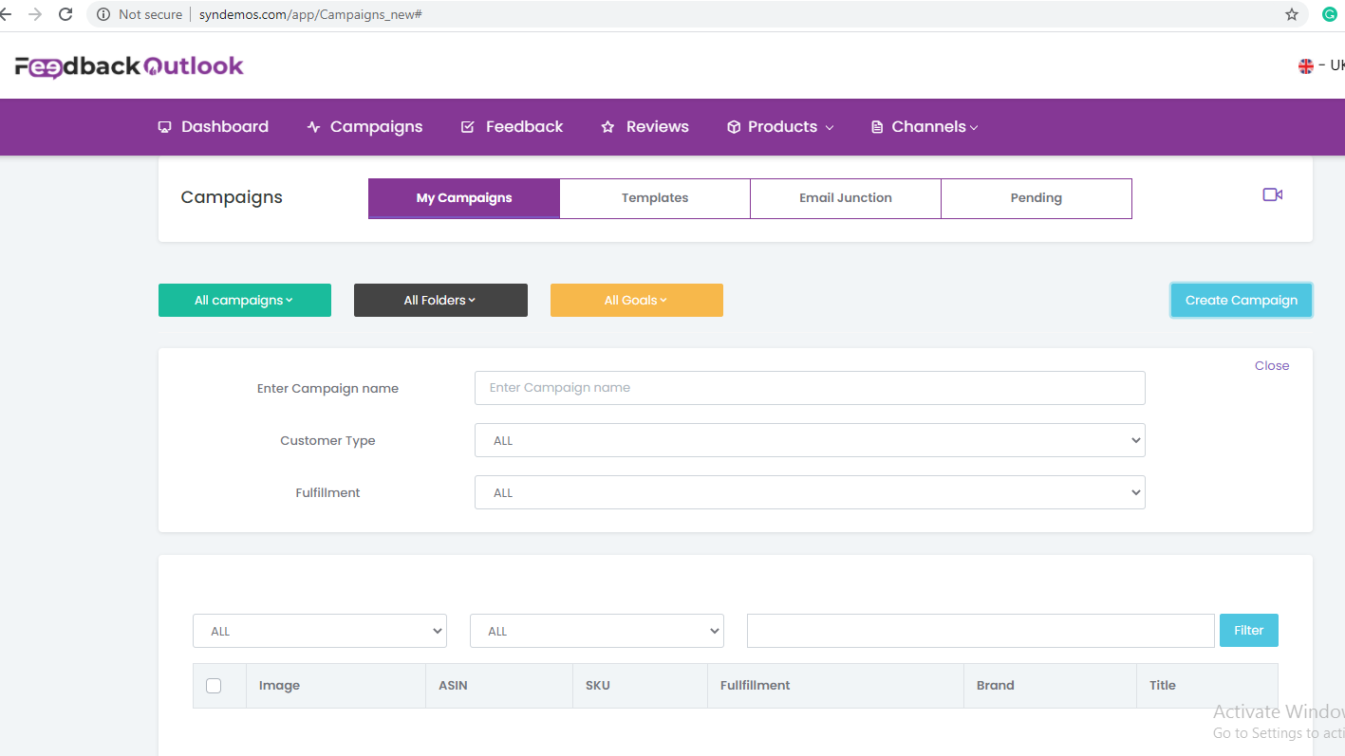

Every campaign needs to have a goal. By setting a **goal type** for your campaign, you can track its success and avoid your customers getting the same type of message multiple times.

There are **3 goal types available**. Below is a short explanation of each.  
  
**Customer Service:**Customer service is a more general goal, aimed at giving the customer a good sense of your service. This might come in the form of asking if there were any delivery issues or maybe a month down the line asking how they are getting on with their purchase.  
  
**Feedback:**This campaign is aimed at getting seller feedback from your customers. Generally, you would ask the customer if they received their package in good order and encourage them to give you some positive feedback.

**Product Reviews:**This campaign is aimed at getting customers to leave reviews for your products. The more reviews (particularly high star reviews) your product has the better its ranking on Amazon, making it much more visible when searching for it. Even if you didn't create the product, it's still of great benefit to get extra product reviews for the products you sell.

Need to add Heading for every section.

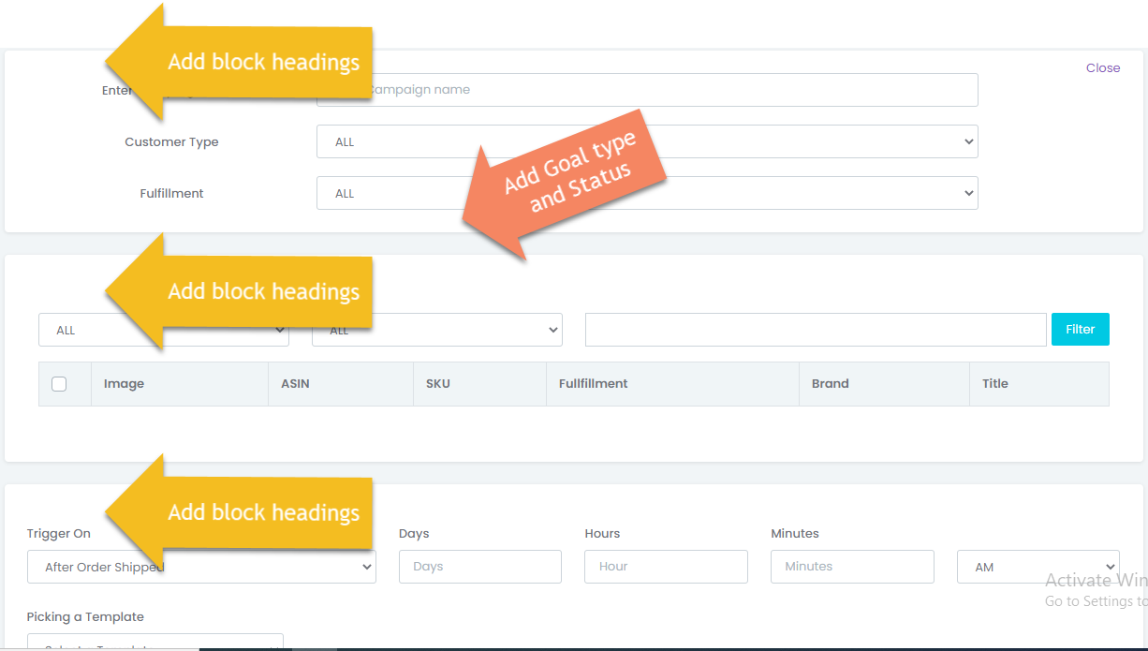

**Feedback Page:**

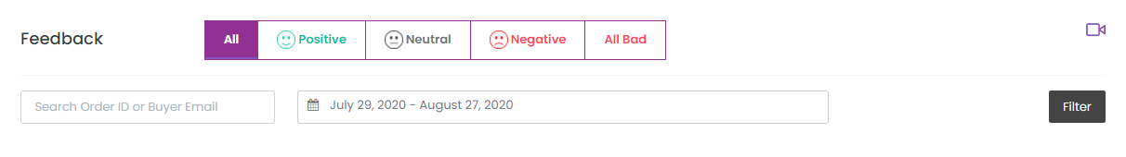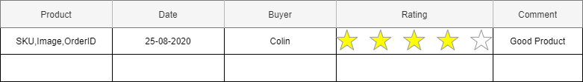

**Review dashboard:**

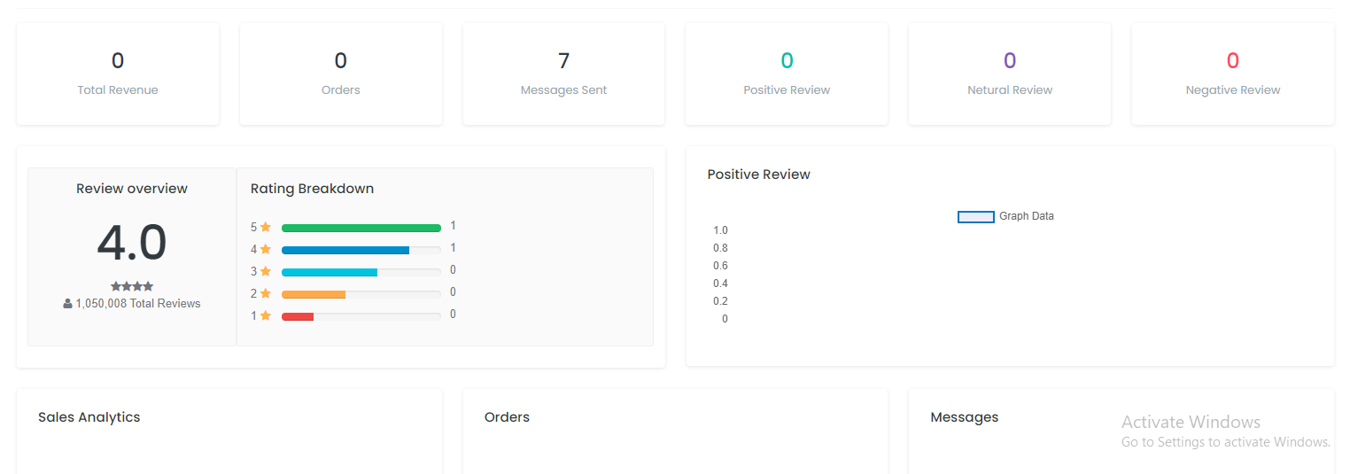

**Reviews Page**

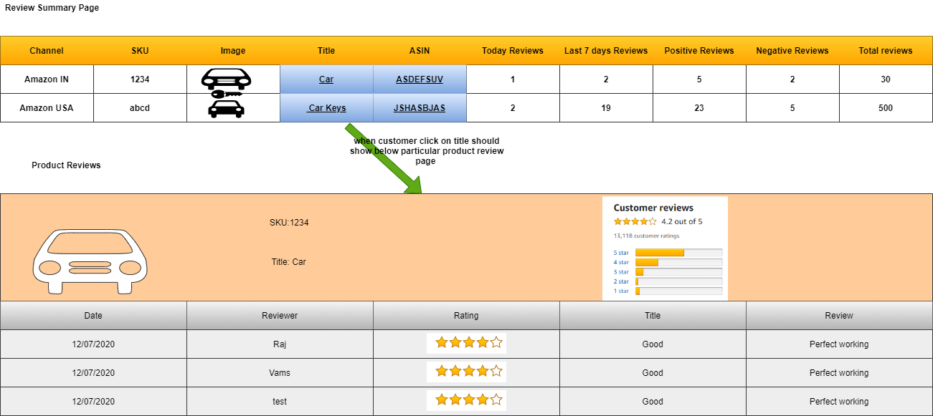

**Review Tracking**

Adding review tracking to your ASINs within FeedbackExpress is so quick and easy. Just simply flick the toggle button to “On”.

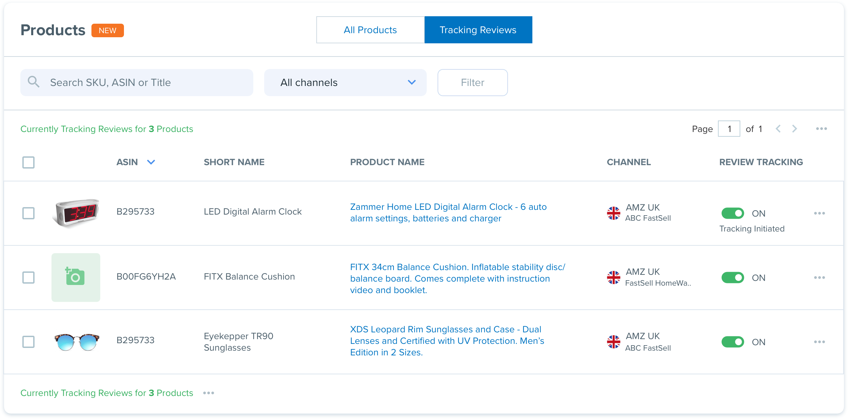

Once it’s switched on, FeedbackExpress will automatically import your product reviews for you to view at a glance within the software.

You can even set up email and/or text message alerts for negative reviews. So, you’ll get alerts even when you’re not logged into FeedbackExpress

feedbackexpress.com/amazon-product-review-tracking-now-available/